Modern Slavery and Human Trafficking Statement for the financial year ended 31 December 2019
The Scot JCB group supplies machinery to the construction and agricultural markets, predominantly in the UK, and provides after-sales support for those products. The group trades as Scot JCB Limited, Stewart Plant Sales, Scot Industrial Air, A M Phillip Agritech, and Kelso and Lothian Harvesters.
During the year we took the following steps to prevent modern slavery from occurring in our business and supply chains.
- We reviewed our supplier list to identify any supplies coming from countries with a high risk of modern slavery. More than 99% of our supplies are from UK companies and in the remainder we do not have any direct supplies from high risk countries.
- For our major UK suppliers we have carried out a supplier audit process to review their slavery policies and statements to ensure they in turn are verifying that their own supply chains are the subject of appropriate audit processes. No slavery risks were identified during this process.
- Within our own workforce we have increased our HR resources in order to ensure that our employment contracts are legally compliant and that our recruitment processes will identify any concerns with job applicants.
- Appropriate staff have been briefed on the Modern Slavery Act 2015 and the risks of slavery and human trafficking in our business and supply chains.
The company also has a Modern Slavery and Human Trafficking Policy which is available on our website.
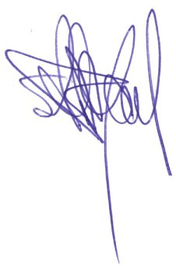
This statement was approved by the board of directors on 20 January 2019 and is signed on its behalf by

Steven C J Bryant
Chairman
10 January 2020

