Scot JCB (Holdings) Limited

Scot JCB Ltd
Stewart Plant Sales
Scot Industrial Air
Kelso and Lothian Harvesters
A M Phillip Agritech

POLICY STATEMENT
QUALITY

Commitment
We are committed to implementing a documented management system which satisfies the requirements of BS:EN:ISO90001:2000, includes quality objectives and meets the needs and expectations of our customers.

We have achieved Achilles UVDB Verify qualification.

Objectives
Quality objectives include but are not restricted to providing products and support services which satisfy customer requirements, minimise returns and complaints and provide opportunities to maximise sales and minimise costs without compromising compliance with statutory regulations.

Continual Improvement
This policy has been communicated to all employees who are encouraged to feed back
information which may enhance customer satisfaction.
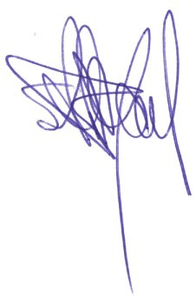
Policy and management systems are reviewed at six monthly management review meetings.

Signature : Date : 10/01/2020
S C J Bryant - Chairman

